**CPSC 4040 Final Report**

*Josh Hunt*

**Project Overview**

**Goal:** Write a program that can encode and decode images into/from each other.

**Methodology:**

*Encoding:*

1. Read in and store both images (image being modified and image to be hidden)
2. Eliminate any alpha channels to help prevent any artifacts
3. Resize the image to be hidden by ¼ of its original size
   * This helps prevent the problem of running out of space to store the hidden image inside of the original
4. Loop through the original image to store the hidden image
   * For each byte (NOTE: for the first 32 bytes the hidden image size is stored):
     1. AND the byte with 0xFC (1111 1100) to zero out the last two least significant bits
     2. OR the byte with the last two bits of the corresponding data from the hidden image
5. Write the new altered image to a file

*Decoding:*

1. Read and store the image
2. Loop through the image to retrieve hidden data
   * For each byte (NOTE: for the first 32 bytes the hidden image size is stored):
     1. AND the byte with 0x3 (0000 0011) to zero out everything but the two least significant bits
     2. Shift the running buffer over the appropriate amount of space
     3. OR the byte to the current running buffer
3. Write the retrieved hidden image to a file

**Examples:**

In this example the Kermit picture on the left is the original, unaltered image and the one on the right is the image that has been encoded with another (yes, they’re different). To the naked eye, these pictures look identical. However, the image on the right has an image of Jar Jar Binks secretly encoded inside. Here is that image decoded:

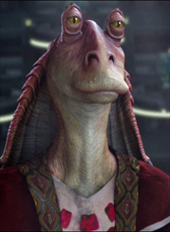

You can see the secret image still has good quality even when compared to the original below:

In this example, the paw on the right has been encoded with a secret image while, the paw on the left is the original. Once decoded this image is retrieved:

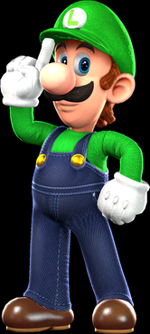

Compared to the original hidden image:

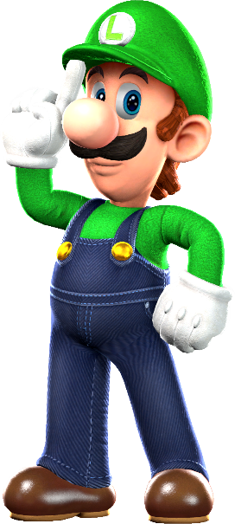

The only visible difference between the two is that the original image has an alpha channel whereas the hidden one does not.

**Retrospective**

In terms of what I initially set out to accomplish I fell a bit short in that originally, I had intended to have the user be able to encode/decode images into the last 4 bits as well. This proved to be harder than I initially thought, and I could not figure out a solution in time. Given more time I would have added this functionality, as well as encoding the length and width of the hidden image into the other image as well as the length. This would make it so that the program could be used with less user input. However, the program works well as is and I feel like I accomplished and learned a lot.